Group Contribution Form

Group Members | Contribution Level | Signatures
Hulusi Ozyahyalar | 10 | 
Kavish Visaria-Shah | 9 | 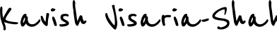
Amy Tidd | 9 | 
Reece Ogidih | 9
Kamal Israni | 9
Radha Kumari Ray | 9 | 